曾顯群 (Endometrial Ca)
- Endometrium 開完刀轉來做RT要注意哪些risk factors, 什麼時候考慮pelvic RT主要集中問IA Gr 1-2, 3 IB Gr 1,2,3的處置 那些時候OBS 那些時候IVRT 那些時候
- risk factors：年齡、腫瘤的侵犯myometrium超過一半、LVSI、grade 2 and 3、
組織型態
- IA Gr 1-2：OBS or IVRT if LVSI and/or ≥ 60歲
- IA Gr 3：IVRT or EBRT if high-intermediate risk (GOG 249)
- IB Gr 1：IVRT
- IB Gr 2：IVRT or EBRT if high-intermediate risk
- IB Gr 3：RT (EBRT and/or IVRT) ± systemic therapy
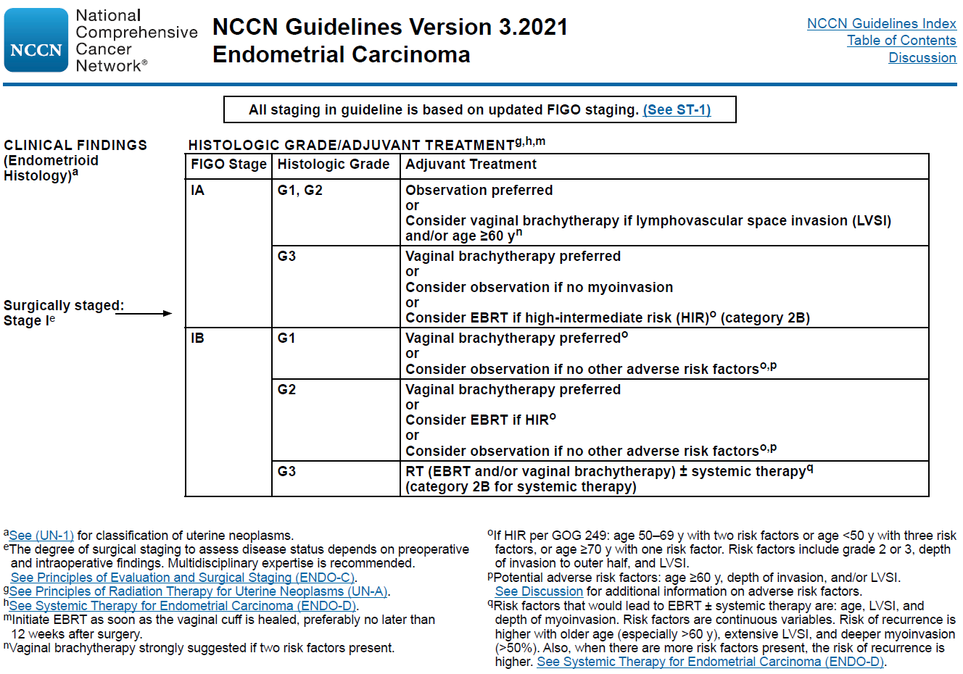
- II：EBRT
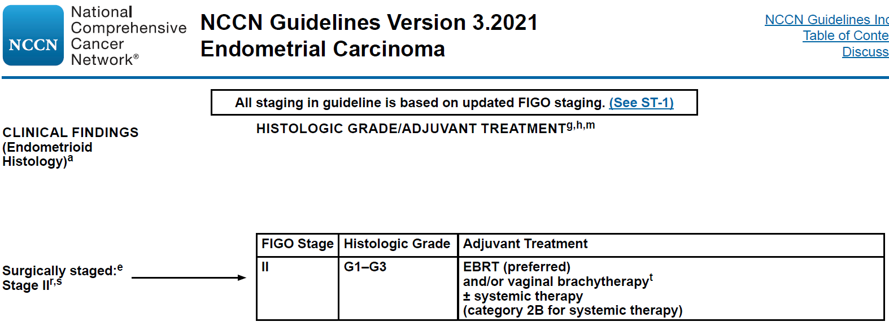

- EBRT 何時考慮化療 (照NCCN回答基本上沒問題)

  - suspected or gross cervical involvement, and not suitable for primary surgery
  - suspected extrauterine disease, and not suitable for primary surgery, locoregional disease
  - stage III, IV
  - disseminated metastases
  - locoregional recurrence
  - high-risk carcinoma histologies (serous carcinoma, clear cell carcinoma, undifferentiated/dedifferentiated carcinoma, carcinosarcoma)
  - uterine sarcoma (high-grade endometrial stromal sarcoma, undifferentiated uterine sarcoma, uterine leiomyosarcoma)
(NCCN ENDO-2, -3, -6, -9, -10, -11, UTSARC-3)

- 你們什麼時候會CCRT

  - suspected or gross cervical involvement, and not suitable for primary surgery
  - suspected extrauterine disease, and not suitable for primary surgery, locoregional disease
  - stage III, IV
  - disseminated metastases
  - locoregional recurrence
  - high-risk carcinoma histologies (serous carcinoma, clear cell carcinoma, undifferentiated/dedifferentiated carcinoma, carcinosarcoma)
  - uterine sarcoma (high-grade endometrial stromal sarcoma, undifferentiated uterine sarcoma, uterine leiomyosarcoma)
(NCCN ENDO-2, -3, -6, -9, -10, -11, UTSARC-3)

- 外科做不做para Ao LND，如果不做的話放腫醫師如何確定staging?
- SLN mapping or para Ao LN sampling, 特別是high-risk tumors such as deeply invasion lesions, high-grade histology, and tumors of serous carcinoma, clear cell carcinoma, or carcinosarcoma; 如果有finding or enlarged lymph nodes再加做後續的para Ao LND；可以藉由abdomen to pelvis CT or MRI，甚至 FDG PET/CT 來確定有沒有para Ao LAP. A meta-analysis assessing the diagnostic performance of FDG PET/CT, MRI, and CT for nodal involvement reported FDG PET/CT had pooled sensitivity of 82% and specificity of 95%, with CT 50% and 92%, and MRI 56% and 91%, respectively
(NCCN ENDO-C 1 of 6)

- 如果有para Ao LAP，照野如何設計，給多少劑量?
- 照野上緣依照臨床的情況，最少要高於腎臟血管 1-2 cm，但如果淋巴結的侵犯的位置更高的話，以完整地包覆侵犯淋巴結為主，EBRT 45-50 Gy，被侵犯的淋巴結，在organs at risk 允許下，EBRT 60-65 Gy
(NCCN UN-A 1 of 2)

- 問你們醫院brachy RT劑量怎麼給
- For postoperative HDR IVRT alone：6 Gy $×$ 5 fx. to vaginal surface；7 Gy $×$ 3 fx. or 5.5 Gy $×$ 4 fx. to 0.5 cm below vaginal surface
For boost to EBRT, 4-6 Gy $×$ 2-3 fx. to vaginal surface
(NCCN UN-A 2 of 2)

- 有沒有自己做過 Brachy, 會不會切CT, 怎麼知道applicator位置正確, 通常治療多長的陰道

  - 沒有risk factor, 治療不要超過近端2/3的陰道
  - Extensive LVSI or positive margin, 治療全部的陰道
(NCCN UN-A 2 of 2)
====
許文林 (Cervical Ca)
一疊白紙，表格來自趙坤山老大的書，全部變空白填寫答案
第一頁寫2009 FIGO stage對應的淋巴轉移機率Pelvic LN, PA node, 5yr OS
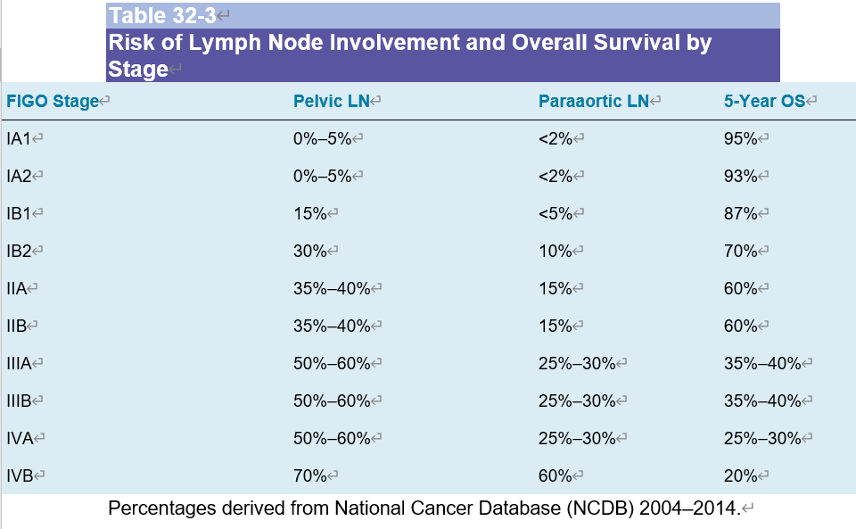

第二頁寫各stage RT的處置 (RT or OP or CCRT..等等)
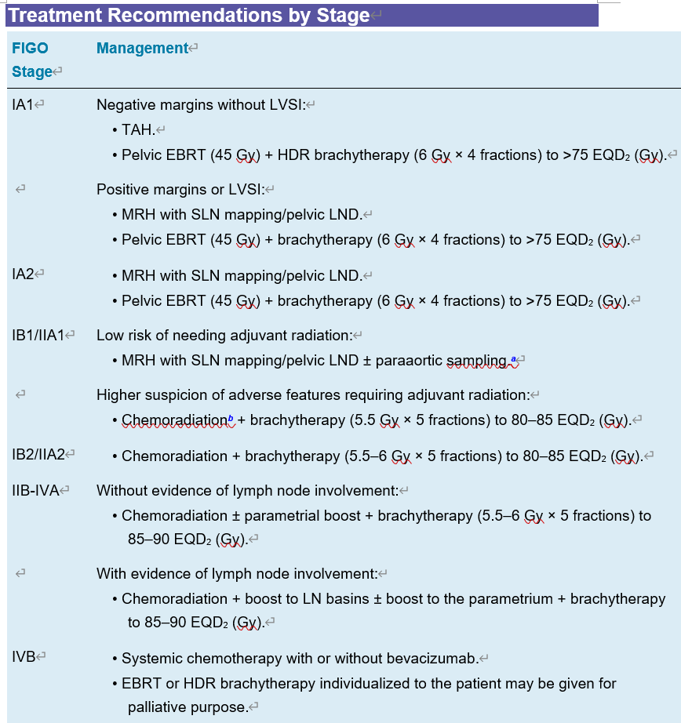
第三頁寫 EBRT劑量, ICRT boost的劑量
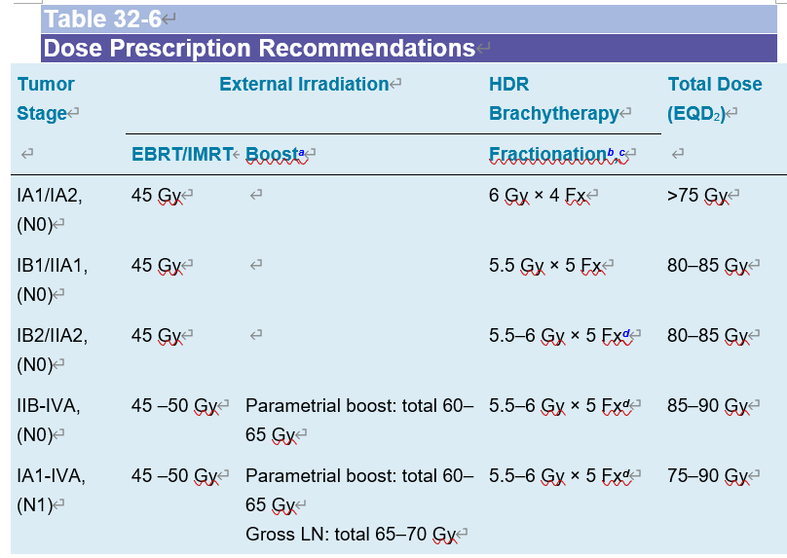

第四頁寫 EBRT的target，GTV, CTV1, CTV2, CTV3, ITV, PTV
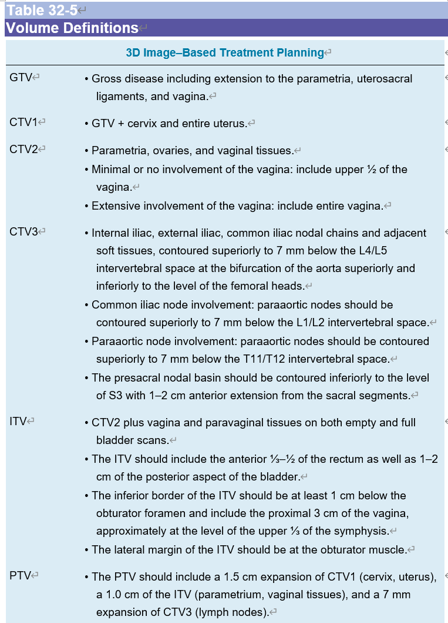
第五頁寫 ICRT的point A, B, bladder point, rectum point, vaginal wall point的位置 (白紙自己畫或寫)
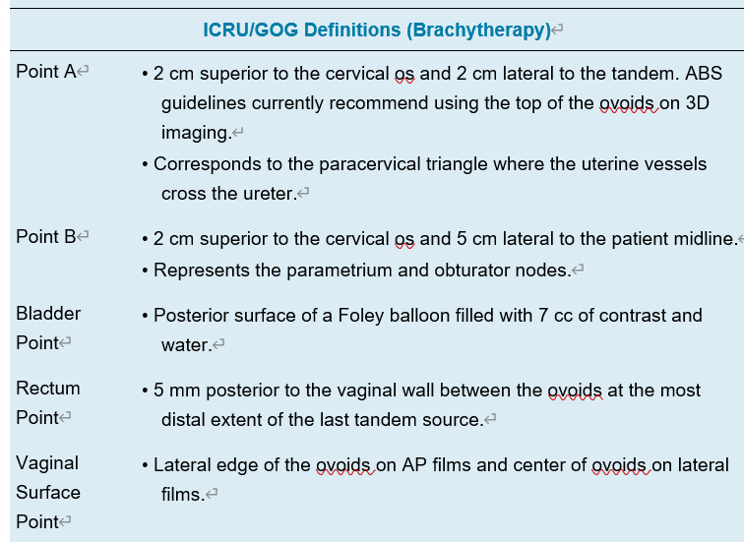
第六頁寫最新FIGO改了什麼
Ans. 將原本的FIGO IB1分期，分成FIGO IB1，腫瘤小於2cm，和FIGO IB2，腫瘤介於2到4 cm，原本的FIGO IB2變為FIGO IB3；並增加了對區域淋巴結侵犯的分期，只侵犯到骨盆腔淋巴結，FIGO IIIC1，侵犯到主動脈旁淋巴結，FIGO IIIC2。
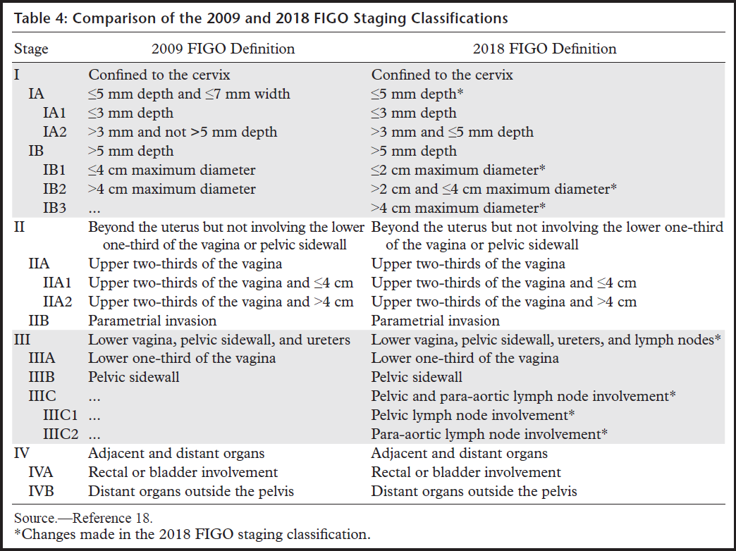

-----------------------------------------------------------------------------------------------------------------附上老師本來要出的題目 供大家參考
- Cervical cancer
- 請問子宮頸癌 2018年版的FIGO stage 相較於2009年版，作了甚麼改動？
- 將原本的FIGO IB1分期，分成FIGO IB1，腫瘤小於2cm，和FIGO IB2，腫瘤介於2到4 cm，原本的FIGO IB2變為FIGO IB3；並增加了對區域淋巴結侵犯的分期，只侵犯到骨盆腔淋巴結，FIGO IIIC1，侵犯到主動脈旁淋巴結，FIGO IIIC2。

- Revised FIGO staging for carcinoma of the cervix uteri, International Federation of Gynecology and Obstetrics 2019; 145: 129–135

- 請問子宮頸癌患者，如果經影像檢查，只有Parametrial invasion，無adenopathy，請問此時建議何種治療方式？
- 患者此時分期為FIGO IIB，建議Pelvic EBRT + concurrent platinum-containing chemotherapy + brachytherapy；不建議手術治療。

- NCCN guideline Cervical Cancer version 2.2020 CERV-6

- 子宮頸癌患者，經影像檢查，確定有Para-aortic lymph node invasion，建議接受 Extended-field EBRT + concurrent platinum-containing chemotherapy + brachytherapy。請問Extended-field EBRT Contour 的上緣建議和請敘述GOG 125的結果？
- Contour上緣建議為renal vessels；但如果淋巴結的侵犯的位置更高的話，以完整地包覆侵犯淋巴結為主。
GOG 125為Phase II trial，想要探討子宮頸癌stage I-IVA的患者，經切片確定有para-aortic node metastases，在給予Pelvic RT之餘，加上Extended-field RT 4500 cGy，同時合併5-Fu和Cisplatin。3-year overall survival為39%，3-year progression-free interval為34%。復發部位of recurrence：pelvis alone, 20.9%; distant metastases only, 31.4%; and pelvic plus distant metastases, 10.5%。

- NCCN guideline Cervical Cancer version 2.2020 CERV-D1
- Cervical carcinoma metastatic to para-aortic nodes: extended field radiation therapy with concomitant 5-fluorouracil and cisplatin chemotherapy: a Gynecologic Oncology Group study, Int J Radiat Oncol Biol Phys. 1998 Dec 1;42(5):1015-23.

- Intracavitary brachytherapy，HDR比LDR多了甚麼優點？這兩種不同的治療方式，會對疾病的local control或是患者的overall survival有影響嗎！？
- HDR：較短的治療，可以改門診治療，病人順從性高、治療完畢即移除裝置，不會散發放射線、較小的治療裝置，減少組織受傷。
根據Brachytherapy 2015年的meta-analysis，兩種治療方式，對於患者的5-year survival, 5-year DFS, and pelvic recurrence, and complication rates of the rectum and bladder 沒有差別

- High-dose-rate vs. low-dose-rate intracavitary brachytherapy for carcinoma of the uterine cervix: Systematic review and meta-analysis, Brachytherapy 14 (2015) 449e457
- Endometrium cancer
- 子宮內膜癌患者，Surgically stage FIGO IA, G3，請問後續的建議方式為何？
- 依照risk factors有以下兩種建議治療方式
- 1. Vaginal brachytherapy or consider observation if no myoinvasion
2. Consider EBRT if high-intermediate risk, age < 50 y with 1 risk factor,
age 50-69 y with 2 risk factors or age > 70 y with 3 risk factors.
Risk factors:
- grade 2 or 3
- depth on invasion to outer half
- lymphovascular space invasion

- NCCN guideline Uterine Neoplasms, version 2.2020 ENDO-4

- 請論述PORTEC-2 trial和GOG 249 trial，並分析其結果
- PORTEC-2 trial：stage I or IIA endometrial carcinoma with high-intermediate risk, 接受手術後，分成pelvic EBRT 46 Gy/23 fx. 或 vaginal brachytherapy 21 Gy/3 fx. 兩組在 5-year vaginal recurrence, 5-year locoregional relapse, 5-year distant metastases 沒有差別；但在10年後的追蹤報告中，10-year pelvic recurrence 於 vaginal brachytherapy 組明顯升高。EBRT 提供了更好的pelvic control.

GOG 249 trial：
- stage I with high-intermediate-risk
- stage II
- stage I-II serous or clear cell tumors

接受手術後，分成 EBRT組 45-50.4 Gy 或 vaginal brachytherapy followed by paclitaxel + carboplatin. 兩組在5-year overall survival 沒有差別; 但是pelvic or para-aortic nodal recurrence 於 vaginal brachytherapy 組明顯升高。

綜合兩個trials的結果，對於early stage high-intermediate risk endometrial carcinoma的患者，在手術後，選擇EBRT治療，相比於vaginal brachytherapy + Cisplatin followed by paclitaxel + carboplatin 或是vaginal brachytherapy, 會有較佳的pelvic control 的效果。

- Vaginal brachytherapy versus pelvic external beam radiotherapy for patients with endometrial cancer of high-intermediate risk (PORTEC-2): an open-label, non-inferiority, randomised trial, Lancet 2010; 375: 816–23
- Ten-year results of the PORTEC-2 trial for high-intermediate risk endometrial carcinoma: improving patient selection for adjuvant therapy, British Journal of Cancer (2018) 119:1067–1074
- Phase III Trial: Adjuvant Pelvic Radiation Therapy Versus Vaginal Brachytherapy Plus Paclitaxel/ Carboplatin in High-Intermediate and High-Risk Early-Stage Endometrial Cancer, J Clin Oncol. 2019 Jul 20;37(21):1810-1818.

- 請論述PORTEC-3 trial
PORTEC-3 trial：
- stage I with high risk endometrial cancer
- endometrioid-type grade 3 with deep myometrial invasion or lymph-vascular space invasion
- endometrioid-type stage II or III with serous or clear cell histology

手術後分成 adjuvant RT 48.6 Gy/27 fx. 或是 adjuvant CCRT 48.6 Gy/27 fx. with Cisplatin and followed by Carboplatin + Paclitaxel. 雖然5-year overall survival 沒有差別; 但是5-year failure-free survival 是adjuvant CCRT組較佳, 雖然伴隨了較嚴重的副作用。

- Adjuvant chemoradiotherapy versus radiotherapy alone for women with high-risk endometrial cancer (PORTEC-3): final results of an international, open-label, multicentre, randomised, phase 3 trial, Lancet Oncol 2018; 19: 295–309
- Ovary cancer
- 請問卵巢癌患者，於腹股溝處摸到腫塊，經切片確診為淋巴結轉移，請問FIGO stage 2014為何？建議的治療方式？
- 因腹股溝淋巴結為non-regional lymph nodes，故為遠端轉移，FIGO stage IVB，先接受Platinum-based chemotherapy，如化療反應佳，再由婦產科醫師評估是否可以進行手術切除。同時考慮標把藥物，Bevacizumab和Olaparib的使用。

- NCCN guideline Ovarian Cancer version 1.2020 OV-4, ST-1, ST-2
- Vaginal cancer
- 原發的vaginal cancer的組織學型態多為何？請簡單介紹其FIGO stage?
- 85%為squamous cell carcinoma, 其它還有melanoma (4%), sarcoma (3%), Malignant Mixed. Müllerian Tumor, clear cell adenocarcinoma, other adenocarcinoma, lymphoma
FIGO stage I: 腫瘤侷限在陰道壁
FIGO stage II: 腫瘤侵犯到 subvaginal tissue但是沒有侵犯到 pelvic wall
FIGO stage III: 腫瘤侵犯到 pelvic wall
FIGO stage IVA: 腫瘤侵犯到 mucosa of the bladder 或 rectum 或 direct extension beyond the true pelvis；bullous edema is not sufficient to allow classification
FIGO stage IVB: 遠端轉移

- Peres 7th. Chapter 76 Vaginal Cancer p.1791
- Vulvar cancer
- 請問early stage vulvar cancer 患者，接受手術治療，SLN biopsy 確定有0.2 cm的轉移淋巴結並接受complete inguinofemoral lymphadenectomy，病理結果確定有3顆轉移的淋巴結，請問後續adjuvant RT的治療規劃？
- Primary surgical bed (negative margins) = 45-50 Gy
Primary surgical bed (positive margins) = 54-60 Gy
Clinically and/or radiographically uninvolved inguinofemoral LNs = 45-50 Gy
Inguinal LNs (positive, no ENE or gross residual disease) = 50-55 Gy
Inguinal LNs (ENE) = 54-64 Gy
Inguinal LNs (gross residual or unresectable disease) = 60-70 Gy

Organs at risk: rectum, bladder, small bowel, femoral head, femoral neck
因vulvar位於身體表淺處，需考慮bolus。

- NCCN guideline Vulvar Cancer version 3.2020 VULVA-D4

